SEQUENCE DIAGRAM

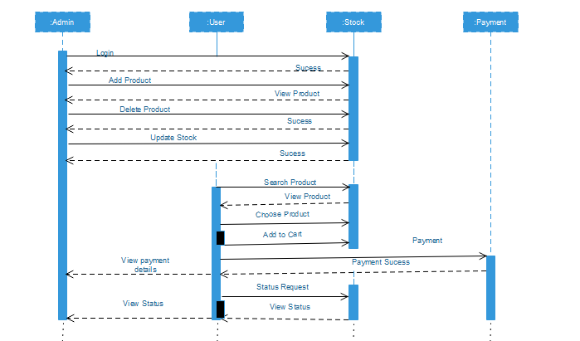

USECASE DIAGRAM

For User Login, View Items and Checkout Product by Customer

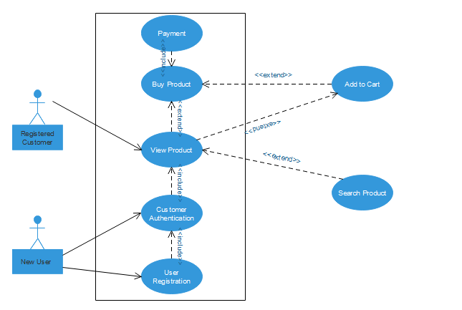

For Adding/Updating Stock

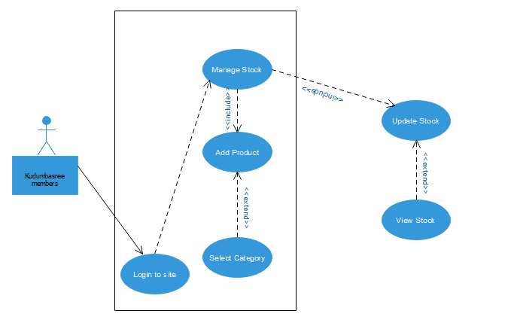

ACTIVITY DIAGRAM

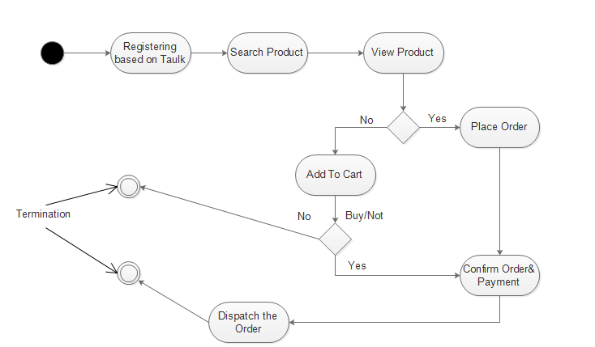

COLLABORATION DIAGRAM

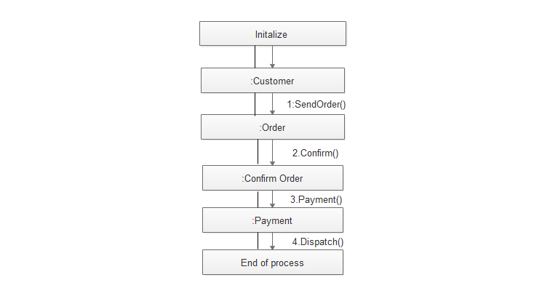

STATE DIAGRAM

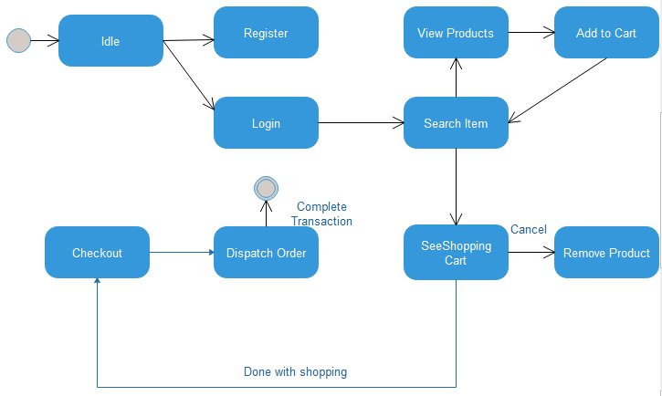

CLASS DIAGRAM

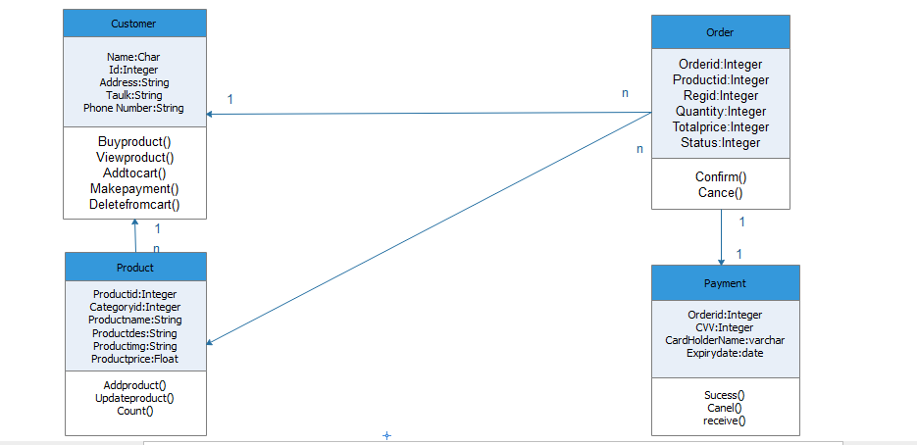

OBJECT DIAGRAM

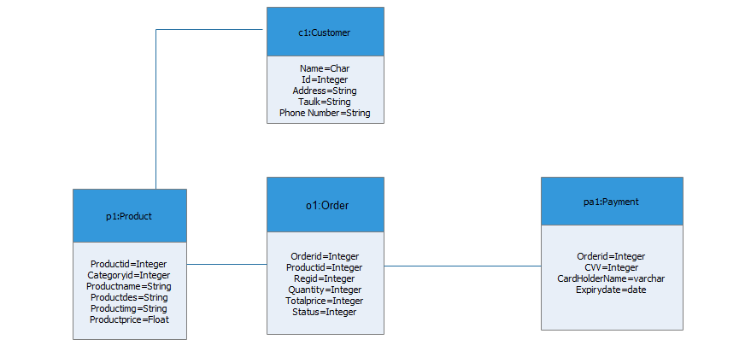

DEPLOYMENT DIAGRAM

